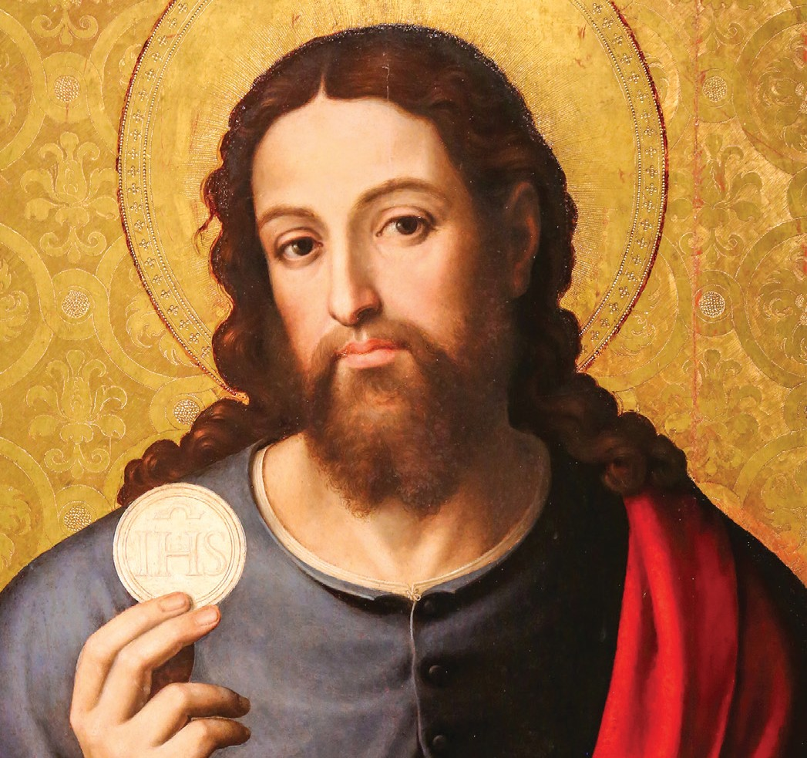
WALK
A B I B L I CA L
MASS
TH RO U G H TH E

How to Use the Pulpit Announcements for Your Parish Bible Study
A Bible study announcement that can be given during the announcements at the end of Mass.
Simply insert your parish name and the details of your study, and voila!
The announcement is ready to go. Please make any additional edits as needed.

SAMPLE PULPIT ANNOUNCEMENT
The Mass is nothing short of amazing. Through it, we encounter God in the most intimate way possible as we hear him speak to us in the Liturgy of the Word and as we receive him Body and Blood, Soul and Divinity in the Holy Eucharist.
The words, the gestures, and the rituals of the Mass are rich in meaning. Everything we say and do in the Liturgy is steeped in biblical language. In his video-based study A Biblical Walk Through the Mass, Dr. Edward Sri explores the roots of the words and gestures we experience at Mass and explains their profound significance. This fascinating tour of the Mass will renew your faith and deepen your love for and devotion to the Holy Eucharist.
[Parish name] in [city/town] will study A Biblical Walk Through the Mass beginning [date] at [time] and continuing every [day] for [number] weeks. For more information or to register for the study, call [name] at [number] or via email: [email address]. We hope you can join us!

