
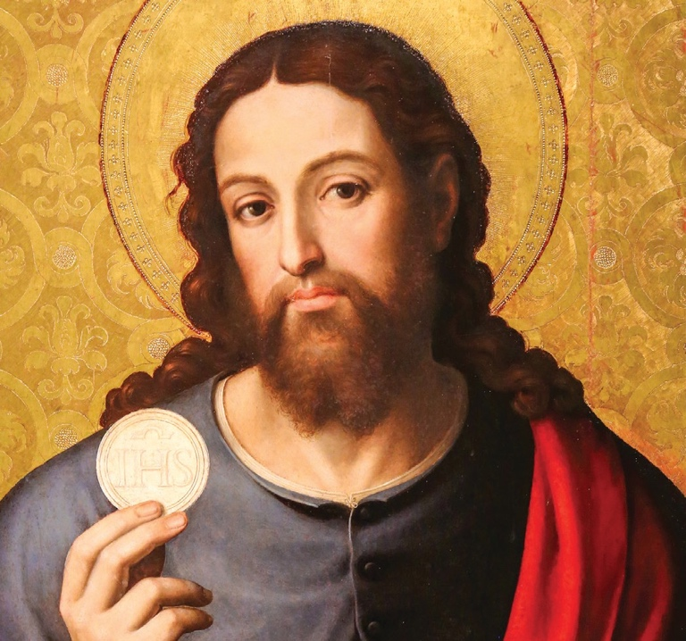
WALK
A B I B L I CA L
MASS
TH RO U G H TH E

How to Use the Bulletin Announcements for Your Parish Bible Study
All you have to do is fill in your parish information and place it in the bulletin.
Please make any additional edits as needed.

SAMPLE BULLETIN ANNOUNCEMENT
The Mass is nothing short of amazing. Through it, we encounter God in the most intimate way possible as we hear him speak to us in the Liturgy of the Word and as we receive him Body and Blood, Soul and Divinity in the Holy Eucharist. In his video-based study A Biblical Walk Through the Mass, Dr. Edward Sri explores the roots of the words and gestures we experience at Mass and explains their profound significance. This fascinating tour of the Mass will renew your faith and deepen your love for and devotion to the Holy Eucharist.
Join us for A Biblical Walk Through the Mass at [parish] in [city/town] beginning [date] from [times] and continuing every [day] for [number] weeks. For more information or to register for the study, call [name] at [number] or via email: [email address].

