



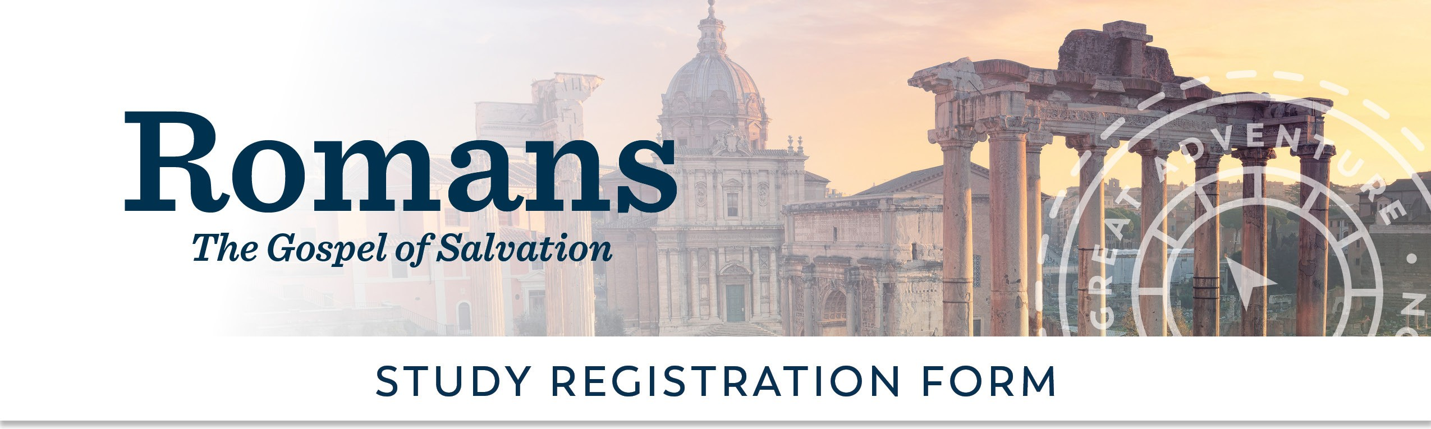
Visit ascensionpress.com to learn more about
The Great AdventureTM Catholic Bible Study Program.
[Subhead Goes Here In Two Lines]
To request financial assistance please email
at
or call
.
Special Needs:
Volunteer Opportunities:
Small Group Facilitator Y/N?
Hospitality Y/N?
Other:
REGISTRATION OPTIONS

Participant Fee: Donation to Scholarship Fund:
Total:

Cash Y/N?: Check Y/N?:
Checks can be made payable to:

and mailed to:

PARTICIPANT INFORMATION

Name: Address:

City: State, Zip: Email:

