



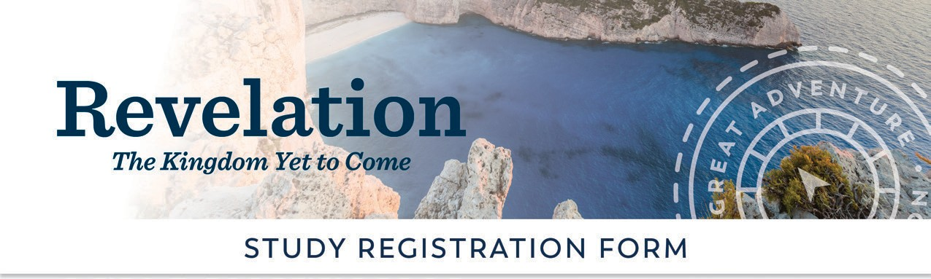

.
at
[Subhead Goes Here in Two Lines]
To request financial assistance, please email
or call
Special Needs:
Volunteer Opportunities:
Small Group Facilitator Y/N?
Hospitality Y/N?
Other:
Visit ascensionpress.com to learn more about
The Great AdventureTM Catholic Bible Study Program.

REGISTRATION OPTIONS

Participant Fee: Donation to Scholarship Fund:
Total:

Cash Y/N? Check Y/N?
Checks can be made payable to: and mailed to:

PARTICIPANT INFORMATION

Name: Address:

City: State, Zip: Email:

