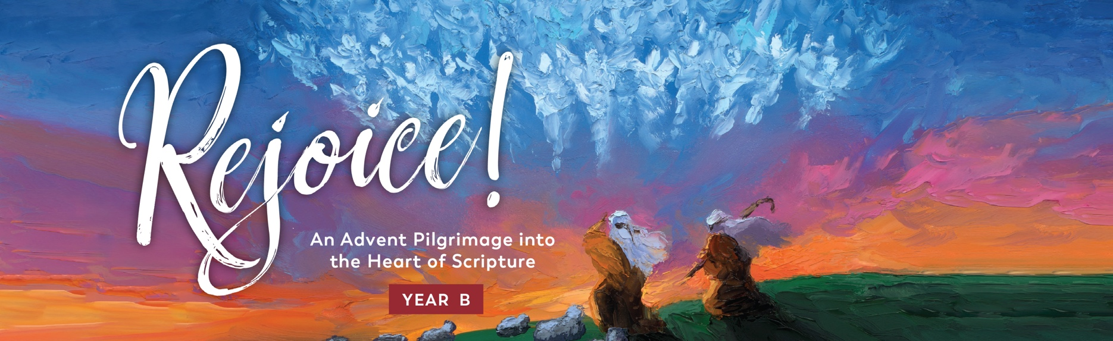

Sample Bulletin Announcement
Advent is a special season for the Church. It is the time when the world prepares to celebrate the coming of Christ. We often lose sight of the point of this season because we get so caught up in our preparations, and we find ourselves no more transformed on Christmas Day than we were at the start of Advent.
One way our parish is seeking to prepare for Jesus’ birth and experience true transformation in this powerful season is by engaging in a new program from Ascension. This program is Rejoice! An Advent Pilgrimage into the Heart of Scripture, Year B. This year, we will explore the Sunday Mass readings through daily reflections, prayer, and journaling, with weekly prayer videos presented by Fr. Mark Toups and his friends Sr. Josephine Garrett and Fr. Josh Johnson.
We have the opportunity to walk together as a parish this Advent, opening our hearts to hear what God is saying to us in this hectic but blessed season. Because we want to take this journey through Advent together, we will be holding an Advent Mission Night on [DATE] at [TIME] in [LOCATION]. Each participant will receive a Rejoice! journal, filled with beautiful art and meaningful meditations, to use throughout the Advent season.
Rejoice! is an opportunity for our whole community to enter the season of Advent intentionally and receive the grace God is waiting to give us in this holy season. Join us for our Advent Mission Night and take full advantage of this transformative experience.

Visit rejoiceprogram.com for more details.


ascensionpress.com

