Sample Bulletin Announcement
Advent is a special season for the Church — it is the time when the world prepares to celebrate anew the coming of Christ. Often, we lose sight of the point of this season because we get caught up in our preparations for Christmas and arrive at Christmas no more transformed than we were at the start of Advent.
A way that our parish is seeking to prepare for Jesus’ birth and experience true transformation in this powerful season is by engaging with a new program from Ascension. This program is Rejoice! Finding Your Place in the Advent Story. This year, we will explore the places, meet the people, and experience the events that shaped the first Advent, and find our place in the story. By immersing ourselves in the environment that God’s people were living in as they prepared for the Messiah, we will experience this sacred season in a new way.
We have the opportunity to walk together on a journey to Bethlehem. Because we want this Advent to be a journey we take together as a parish, we will be holding an Advent Mission Night on [DATE] at [TIME] in [LOCATION]. Each participant will receive a Rejoice! journal, filled with beautiful art and meaningful meditations to accompany him or her throughout the entire Advent season
Rejoice! is an opportunity for our whole community to enter into the season of Advent intentionally and receive the grace God is waiting to give us in this holy season. Join us for our Advent Mission Night and take full advantage of this transformative experience.

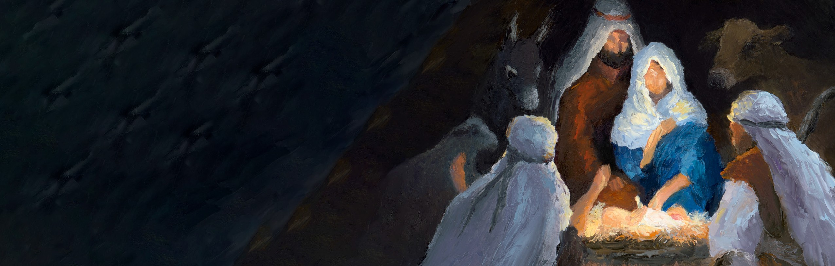Visit rejoiceprogram.com for more details.

Finding Your Place in the Advent Story


ascensionpress.com

