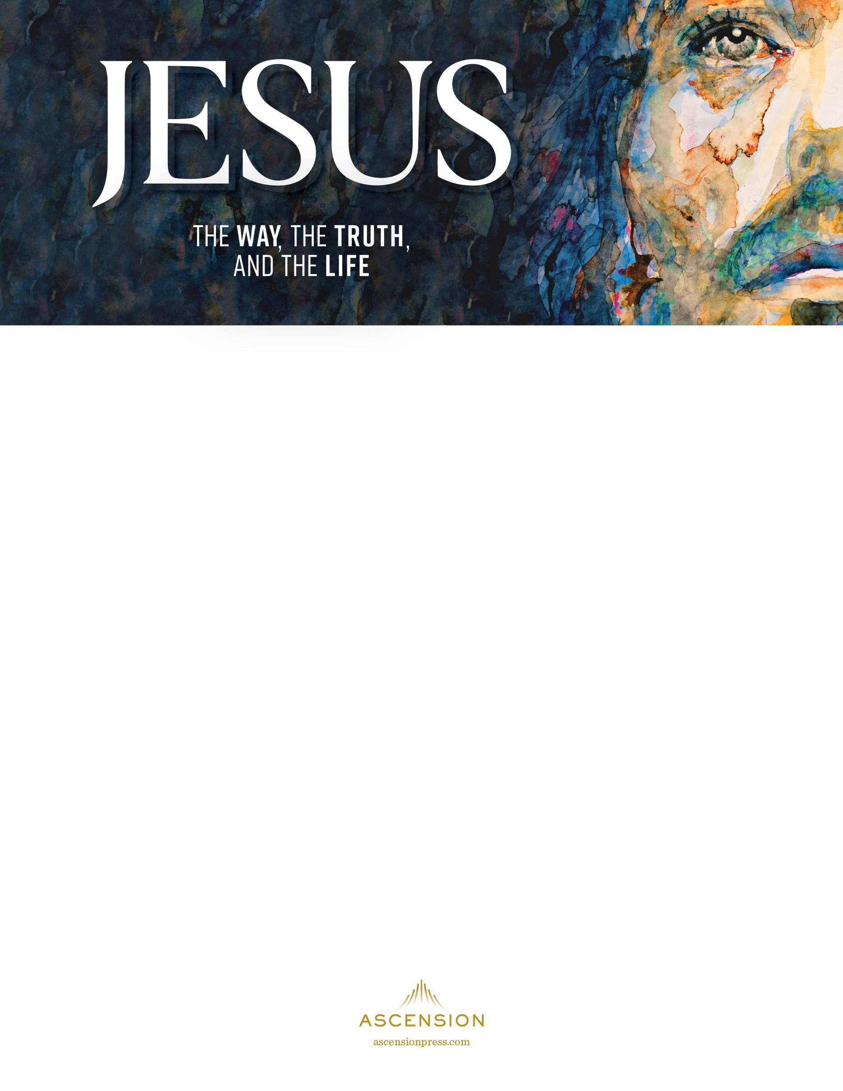

SAMPLE BULLETIN ANNOUNCEMENT
This can be placed in your parish bulletin. Simply insert
your study details and make any other changes you like.
Jesus: The Way, the Truth, and the Life
Jesus is our savior, our redeemer, our Lord, and our God. Our belief in Jesus is what makes us who we are as Catholics, as Christians, but do we really know him as we should? Is Jesus a part of your life, or is he at the center of your life as he should be? We invite you to make him the center of your life by joining us for Jesus: The Way, the Truth, and the Life, a 10-week video study program that explores the entirety of Jesus’ life and what he means for us as Catholics today. [PARISH NAME] will begin the Jesus study on [DATE] at [TIME]. Participants will meet every week to view an engaging video presentation by Marcellino D’Ambrosio, Jeff Cavins, and Edward Sri, followed by a lively group discussion and fellowship. For more information or to register, contact [NAME] at [PHONE NUMBER AND EMAIL]. We hope you can join us!

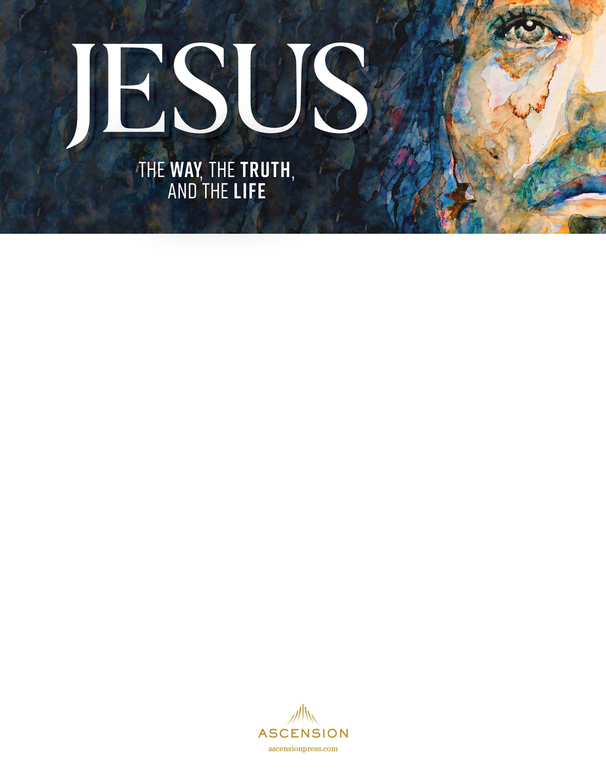

SAMPLE PULPIT ANNOUNCEMENT
This can be delivered by your pastor during your parish’s Mass announcements.
Simply insert your study details and make any other changes you like.
Jesus is our savior, our redeemer, our Lord, and our God. Our belief in Jesus is what makes us who we are as Catholics, as Christians, but do we really know him as we should? Who is Jesus for you? Is he a part of your life, or is he at the center of your life as he should be? We invite you to make him the center of your life by joining us for Jesus: The Way, the Truth, and the Life. This 10-week video study program is anchored in the life of Christ as presented in the Gospels. We’ll explore the entirety of Jesus’ life—who he is, what he is really like, what he taught, what he did for our salvation, and what all of this means for us as Catholics today.
The study is presented by Marcellino D’Ambrosio, Jeff Cavins, and Edward Sri and was filmed in the Holy Land so you can experience the extraordinary world in which Jesus lived and taught—the historical context, the politics, the clashing cultures, the history, and the ancient land—and see where the most significant events of his life took place, from his infancy to his ascension.
We will learn how Jesus is God Incarnate, fully divine and fully human. We’ll experience his intimacy with the Father, his revelation of the Father’s love, and his gift of the Holy Spirit to each of us. Most importantly, our encounter with Christ will empower us to know and love him in a new and life-changing way.
Participants will meet every week to view an engaging video presentation, followed by a time of lively group discussion and fellowship. We will begin the Jesus study on [DATE] at [TIME]. For more information or to register for the study, see [THE INFORMATION TABLE IN THE VESTIBULE / OUR PARISH BULLETIN / OUR PARISH WEBSITE]. We hope you can join us!

