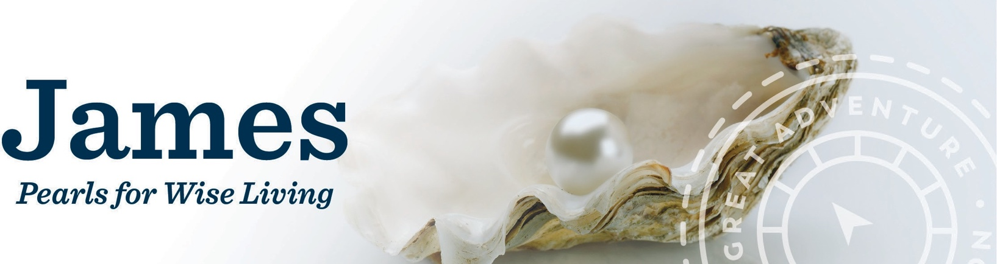

Promotional Announcements

Sample Pulpit Announcement
This can be delivered by your pastor during your parish’s Mass announcements.
Simply insert your study details and make any other changes you like.

Have you ever struggled with living your faith practically? Do you want advice on how to live as a Catholic? James is one of the most practical books of the Bible. Its teachings speak loudly to all those who feel torn between the competing demands of this world and their faith.
James: Pearls for Wise Living, an eleven-week Bible study, offers practical guidance by applying the wisdom of James to our current lives. For anyone who has struggled to live a truly Christian life, James offers a wealth of practical solutions for handling and even sanctifying everyday circumstances.
Participants of James: Pearls for Wise Living will meet every week to view an engaging video presentation followed by a time of lively group discussion and fellowship. Our James Bible study will begin on [DATE] at [TIME]. For more information or to register for the study, see [THE INFORMATION TABLE IN THE VESTIBULE/ OUR PARISH BULLETIN / OUR PARISH WEBSITE], or register online at ascensionpress.com. We hope you can join us!

Sample Bulletin Announcement
This can be placed in your parish’s bulletin. Simply insert your study details and make any other
changes you like.

HEADLINE: James: Pearls for Wise Living

James is one of the most practical books of the Bible. Its teachings speak loudly to those who feel torn between the competing demands of this world and their faith.
This study offers “pearls for wise living” by applying the wisdom of James to our current day. For anyone who has struggled to live a truly Christian life, James offers a wealth of practical solutions for handling and even sanctifying everyday circumstances.
[PARISH NAME] will begin an eleven-week Bible study James: Pearls for Wise Living on [DATE] at [TIME]. Participants will meet every week to view an engaging video presentation followed by a time of lively group discussion and fellowship. For more information or to register, visit ascensionpress.com, or contact [NAME] at [PHONE NUMBER AND EMAIL].

