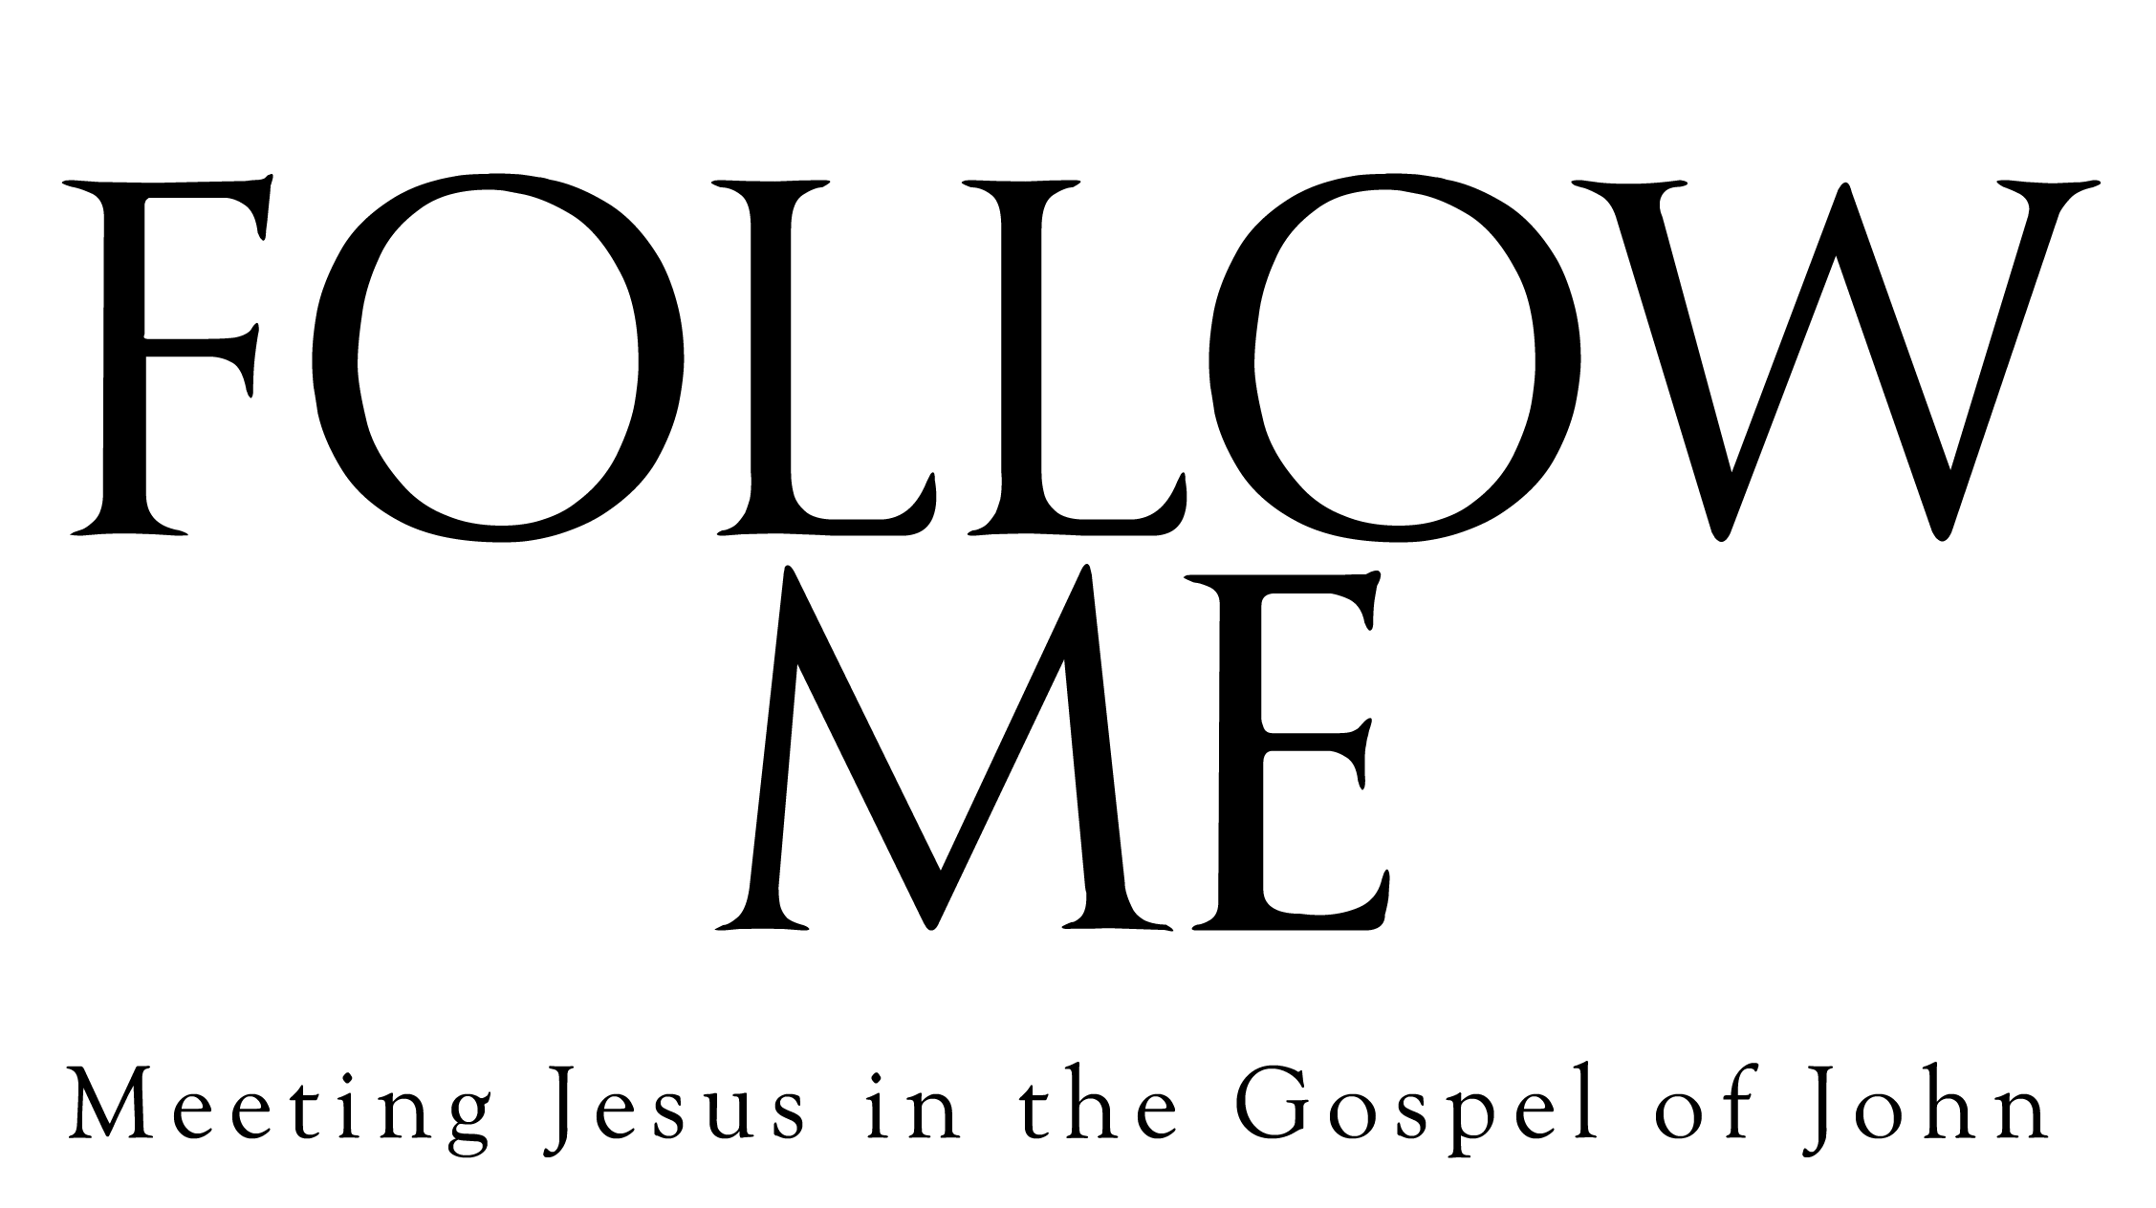
Study Schedule

Dates | Session (Video Times)
 | Introduction (2:18)
 | 1. “In the Beginning”: Jesus at the Center (32:12)
 | 2. “Come and See”: Becoming Disciples (33:46)
 | 3. At the Well: Our Deepest Thirst (31:57)
 | 4. “Believe in Me”: Trust and Surrender (34:27)
 | 5. Encountering Mercy (33:00)
 | 6. The Law of Self-Giving (32:52)
 | 7. The New Commandment and Life in the Spirit (29:56)
 | 8. “It Is Finished”: A Dying and Rising Love (35:30)

