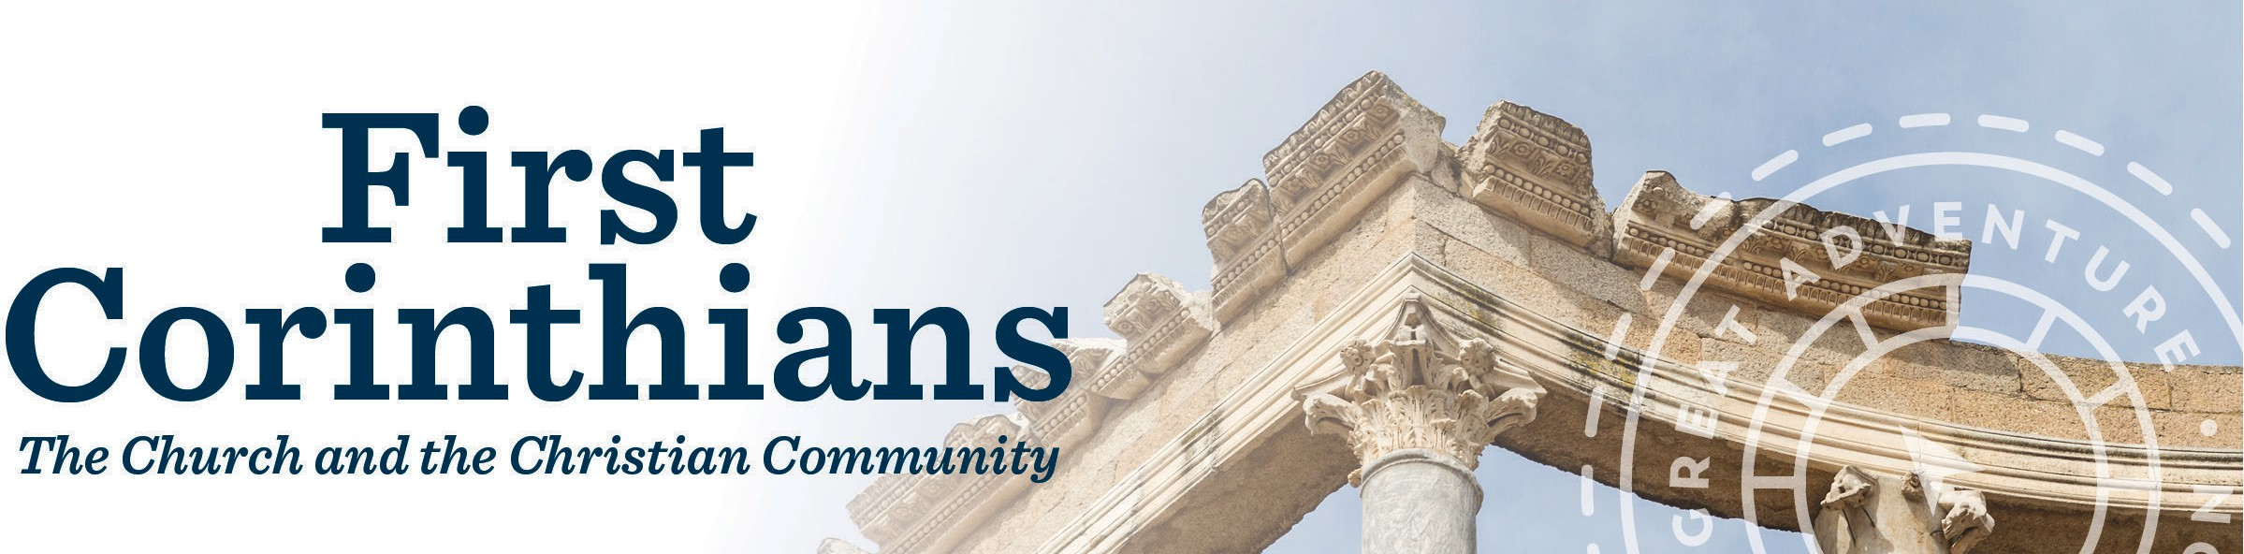

Study Schedule

Date Session (Video Times)
Introduction (28:00)
1. 1 Corinthians 1:1-9: Paul’s Greeting to the Corinthians (27:17)
2. 1 Corinthians 1:10–3:4: Division, Wisdom, and Pride in Corinth (27:45)
3. 1 Corinthians 3:5–4:21: Servants of Christ and His Church Community (28:19)
4. 1 Corinthians 5–7: Immorality – Assimilation Versus Isolation (28:20)
5. 1 Corinthians 8–9: Eating Meat Offered to Idols Versus Love of Neighbor (28:19)
6. 1 Corinthians 10:1–11:1: Imitating Israel in Corinth (28:20)
7. 1 Corinthians 11:2–12:31: True Worship (28:19)
8. 1 Corinthians 13–14: Love and Building Up the Church (28:20)
9. 1 Corinthians 15: Resurrection (28:20)
10. 1 Corinthians 16: Paul’s Closing Words (28:19)

ascensionpress.com

